UNIVERSITY OF LONDON
GOLDSMITHS COLLEGE

B.Sc. Examination 2019

COMPUTING AND INFORMATION SYSTEMS

IS53002B Neural Networks

Duration: 2 hours 15 minutes

Date and time:

This paper is in two parts: part A and part B. You should answer ALL
questions from part A and TWO questions from part B. Part A carries
40 marks, and each question from part B carries 30 marks. The marks
for each part of a question are indicated at the end of the part in
[.] brackets.

Electronic calculators must not be programmed prior to the examination. Calculators which display graphics, text or algebraic equations are not allowed.

THIS PAPER MUST NOT BE REMOVED FROM THE EXAMINATION ROOM

Part A. Question 1.

a) List the main five online (incremental) and offline (batch) training algorithms
for single-layer Perceptrons. [5x1=5]

b) Give the formula of the non-linear function modelled by a multilayer neural
network (using the tanh activation function) and explain each component in it. [5]

c) Describe briefly the algorithm for neural network ensemble averaging. [5]

d) Which are the main five differences between Multilayer Perceptron (MLP) neural
networks and Radial-basis function (RBF) networks. [5x2=10]

e) Compute the updates for weights w₁ and w₃ in the simple multilayer neural
network with two nodes given in the figure below. Assume that the hidden and
the output nodes use the sigmoidal activation function. Perform weight
updating using the backpropagation algorithm with learning rate 0.2.
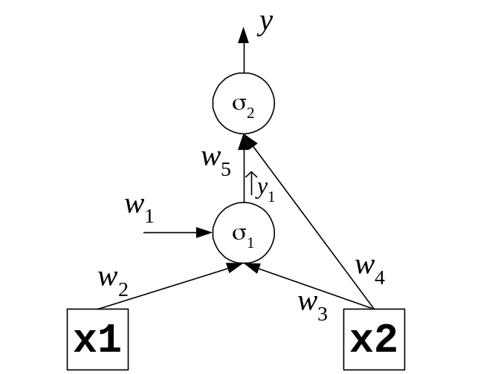

Consider the following initial weights:
w₁ = 0.2 w₂ = –0.5 w₃ = 0.3 w₄ = –0.1 w₅ = 0.15

Use the following training input vector:
x₁ x₂ y
0.1 0.2 0.3

Calculate the node outputs, the error derivatives β (beta), the weight updates, and
the final weights. [4+2x2+3x2+1=15]

IS53002B 2019 TURN OVER
Part B. Question 2.

a) Give the offline (batch) gradient descent training equation for single-layer
Perceptron networks without thresholding activation. [5]

b) Demonstrate the performance of the batch (offline) training algorithm for
unthresholded Perceptron networks. Apply this algorithm to a three input
Perceptron using the following example vectors:

x₁ | x₂ | x₃ | y
0.2 | 0.4 | –0.1 | 0.7
0.5 | –0.2 | 0.3 | 1.2

Start training with the following initial weights: (w₁, w₂, w₃) = (0.2, –0.15,0.1).
Show the weight updates after each example using learning rate η=0.12.
[2+3x2+2+3x2+3x3=25]

IS53002B 2019 TURN OVER
Part B. Question 3.

a) i) State whether Kohonen networks are trained in supervised or
in unsupervised mode, and explain why the mode is used. [3]

ii) Explain briefly what operations the training algorithm for self-organizing
Kohonen networks performs during the competition phase. [5]

b) A self-organizing Kohonen network with 2 neurons each having 3 inputs is given.
Demonstrate training of this network using initial weight vectors
w₁ = (0.1,–0.2,0.3), w₂ = (–0.15,0.2,0.1), and the following input vector:
x = (–0.2,0.1, –0.3).

i) Compute the output of each neuron. [4x2=8]
ii) Determine the index of the winning neuron. [4]
iii) Update the weights of the winning neuron using neighbourhood parameter
h=1.0 and learning rate parameter η=0.2. [5x2=10]

IS53002B 2019 TURN OVER
Part B. Question 4.

a) Discuss briefly how the energy of the Hopfield network changes during the
the training process after the state changes. [5]

b) Give the formula for computing the neuron output in Hopfiled networks. [5]

c) A simple Hopfield recurrent network with 3 neurons and 3 inputs be given for
training. Let the initial weights matrix in this network be:

0 0.2 –0.15
W = 0.2 0 –0.1
–0.15 –0.1 0
i) Demonstrate that the stable state for this network is: [0,0,1]. [3x3=9]
ii) Show that this Hopfiled network is unstable for the second neuron given input
vector [1,0,1], and retrain it. [3+2+2x2+2=11]

IS53002B 2019 END OF EXAMINATION

